# Express.js Retake – Mish-Mash

# Exam rules:

* You have 6 hours – from 10:00 to 16:00
* When you are ready, delete the *node_modules* folder, make sure all dependencies are listed in the *package.json* file and submit your archived project at <https://judge.softuni.bg/Contests/1157/ExpressJS-28-Aug-2018-Retake>
* There will be no breaks during the exam but you can go to the toilet or to breathe some fresh air outside **if you are alone**
* **You are required to edit the provided HTML to make it functional and may extend it as needed.**

# Application Overview

Get familiar with the provided **HTML & CSS** and create an application for media channels, like YouTube, with the difference that everything is mashed up like Mish-Mash. You have been tasked to implement this application by the Indiaver organization. There are several requirements you must follow in the implementation. Below, you will see, how the application should behave, if implemented correctly.

## Database Models

The **Database** of the Mish-Mash application needs to support **2 entities**:

### User

* Has a Username
* Has a Password
* Has an Email
* Has Followed Channels – a collection of Channels.
* Has a Role – can be one of the following values (“User”, “Admin”)

### Channel

* Has a Name
* Has a Description
* Has a Type – can be one of the following values (“Game”, “Motivation”, “Lessons”, “Radio”, “Other”).
* Has Tags – a collection of **Strings**.
* Has Followers – a collection of Users.

Implement the entities with the **correct datatypes**.

## Application Pages

### Guest Pages

These are the **pages** and **functionalities**, accessible by Guests (**logged out** users).

#### Index Page (logged out user)

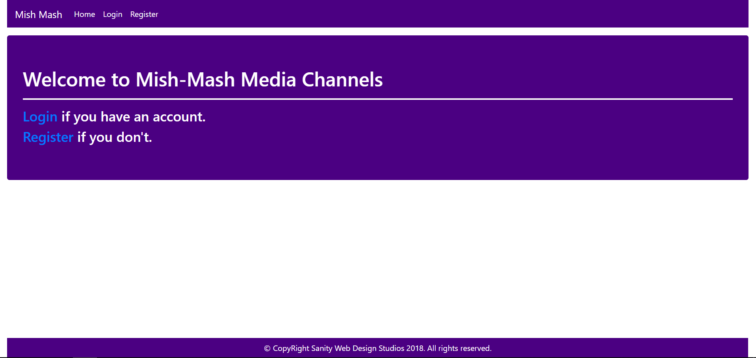

#### Login Page (logged out user)

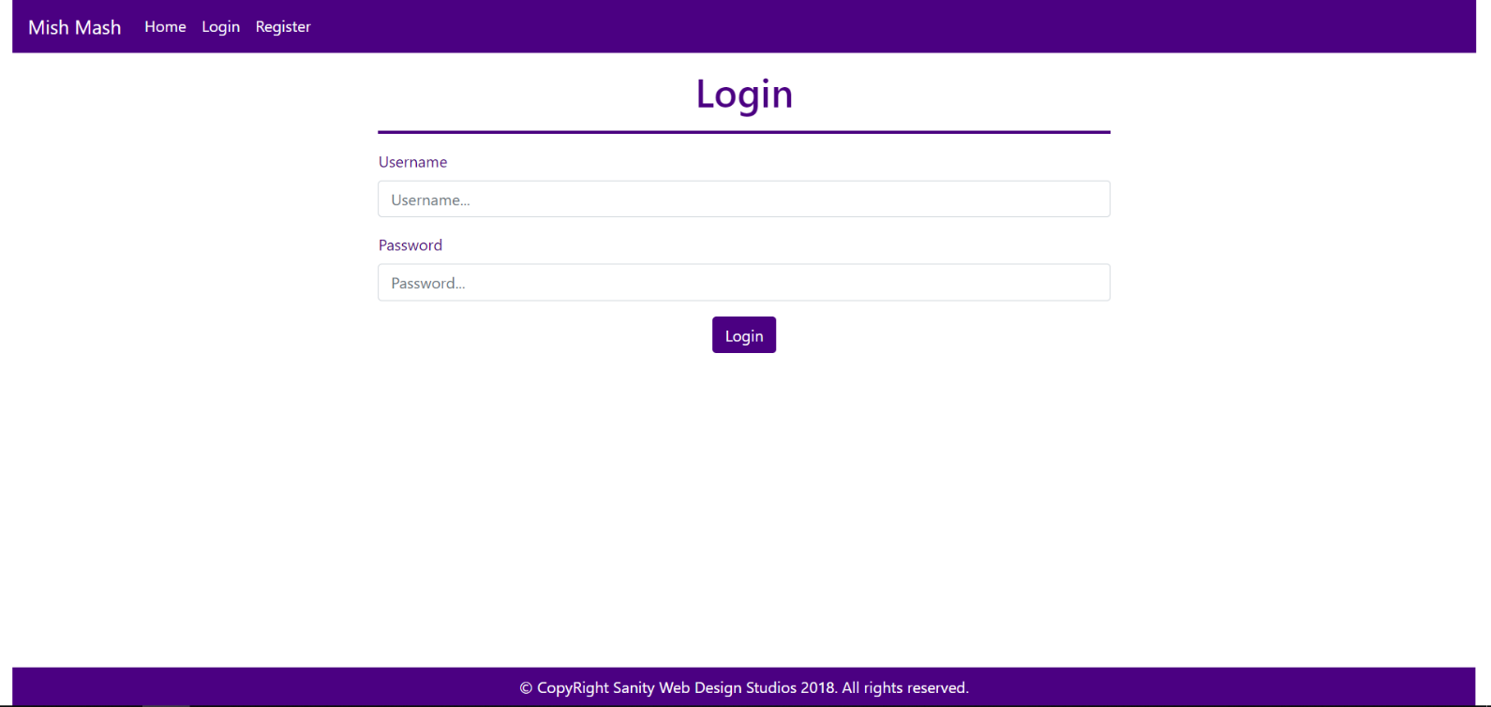

#### Register Page (logged out user)

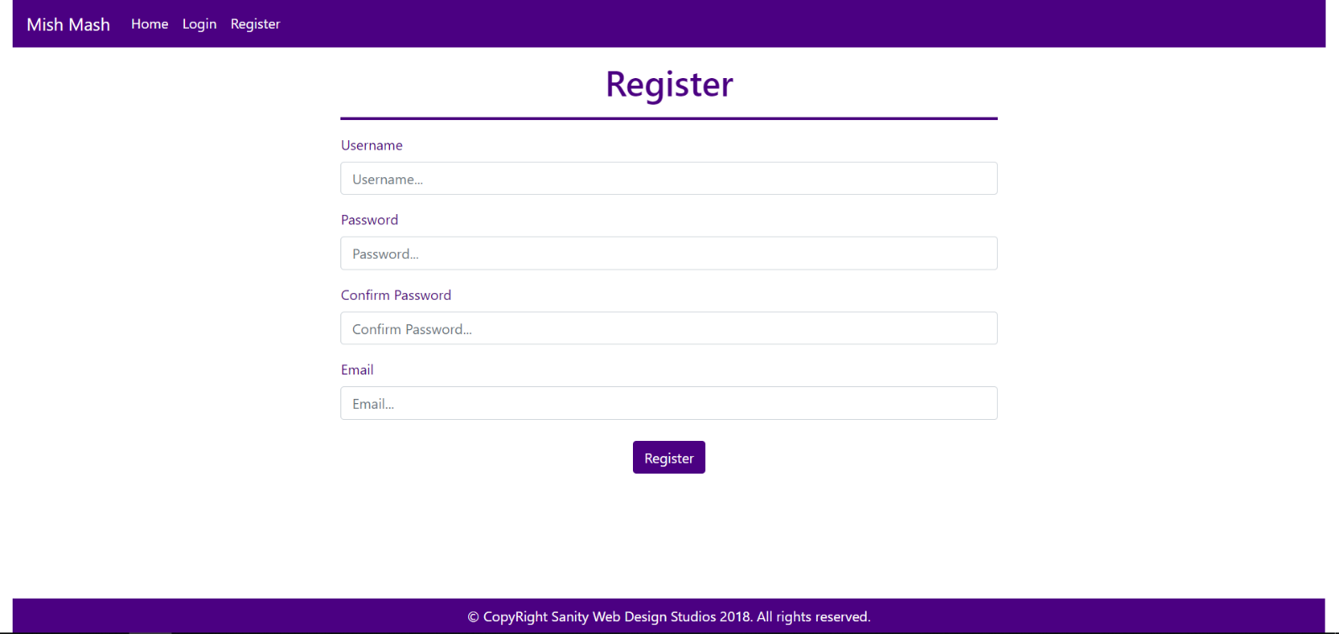

### User Pages

These are the **templates** and **functionalities**, accessible by Users (**logged in** users with Role - User).

#### Logged In Index Page (logged in user)

**NOTE**: As you can see the **elements** are **aligned** to the **left**, **regardless of their count**. The **maximum count** is **5 per** **row**, however they are **always aligned** to the **left**.

##### First

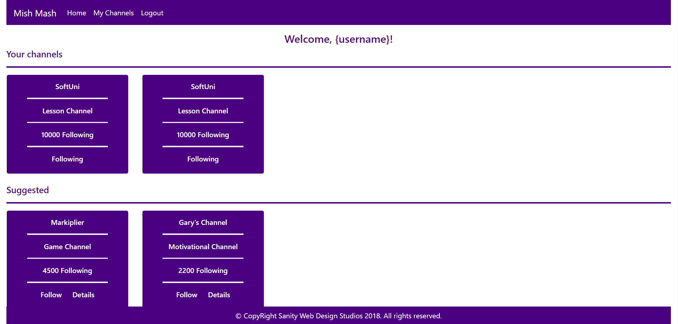

##### Second

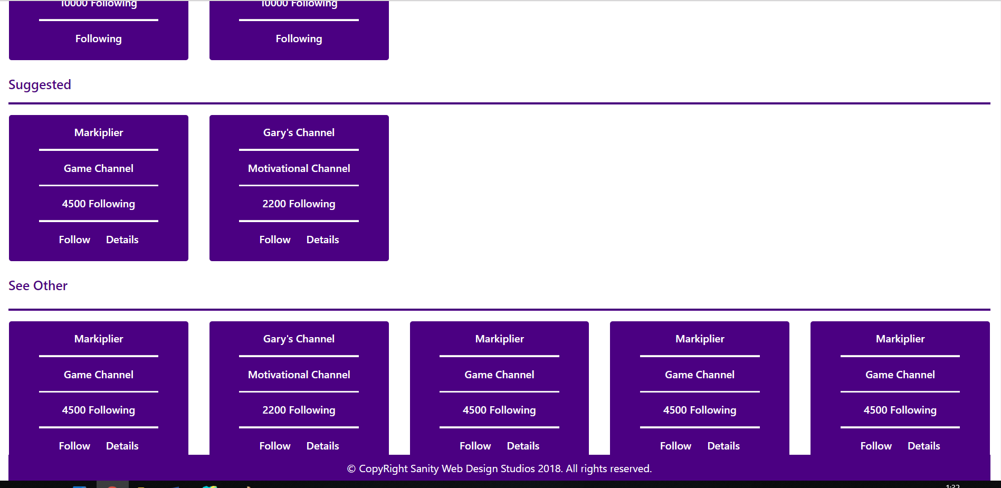

##### Third

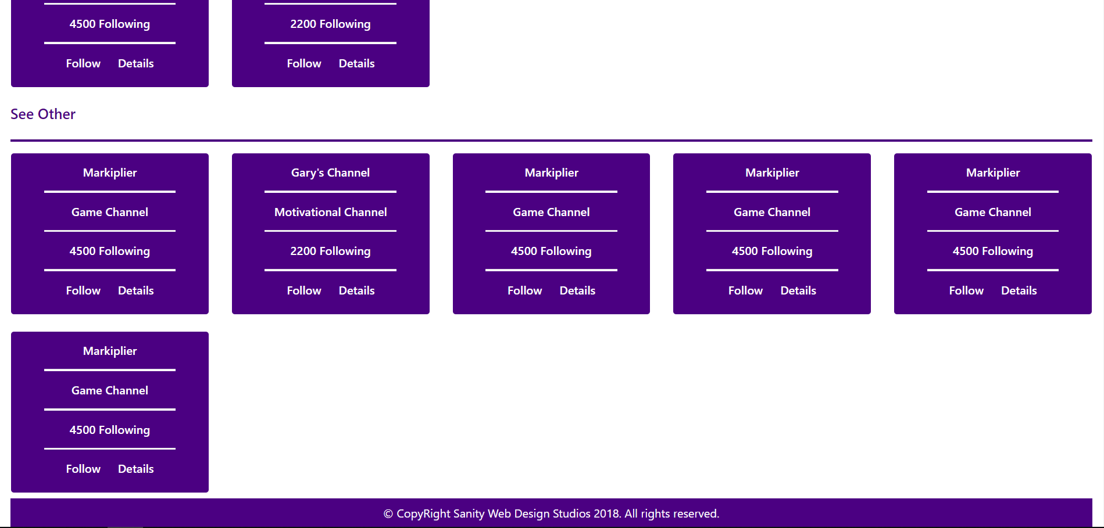

#### Channel Details (logged in user)

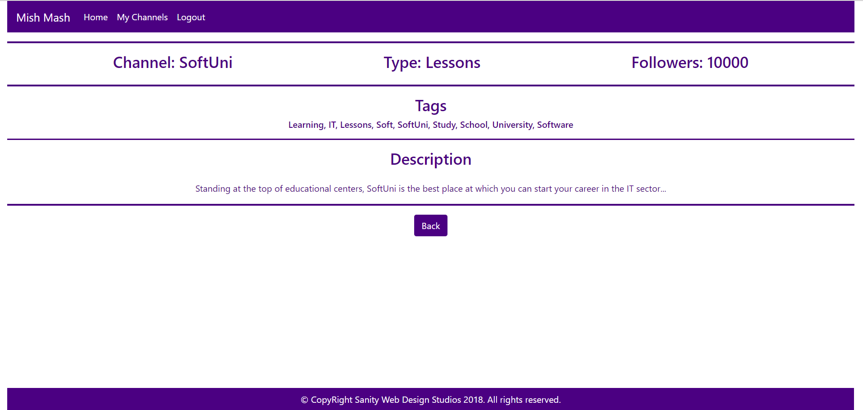

#### My Channels Page (logged in user)

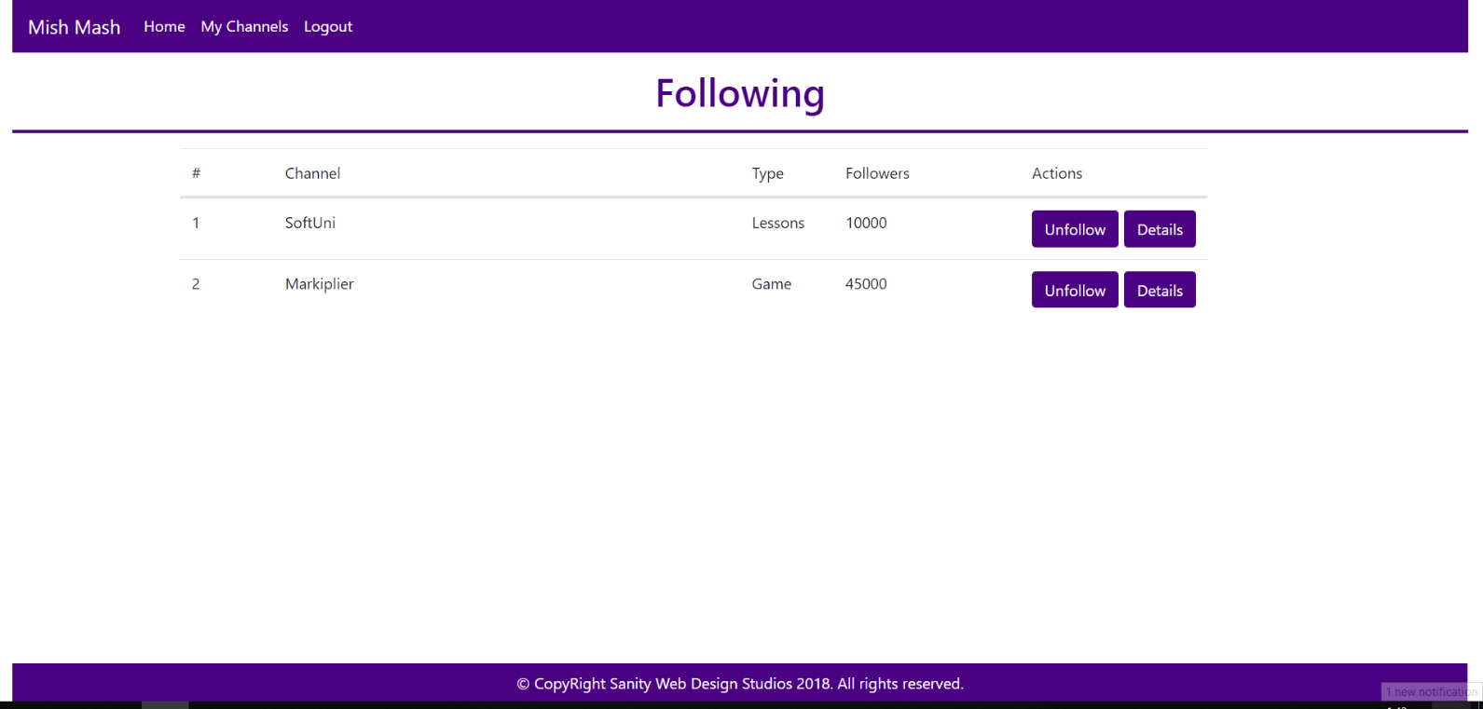

### Admin Pages

These are the **templates** and **functionalities**, accessible by Admins (**logged in** users with Role - Admin).

#### Admin Index Page (logged in admin)

##### First

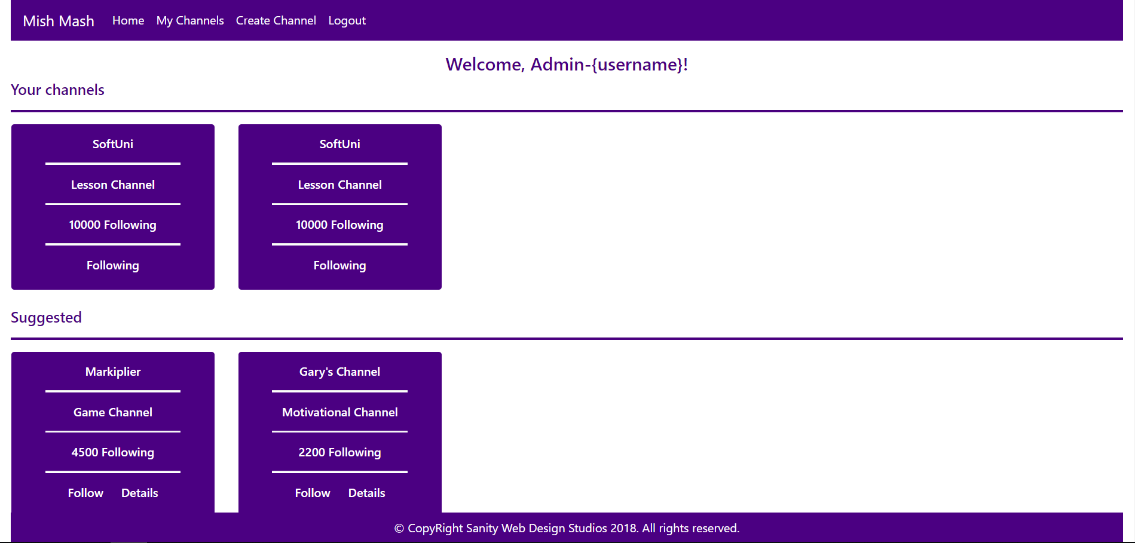

##### Second



##### Third



#### Channel Create Admin Page (logged in admin)

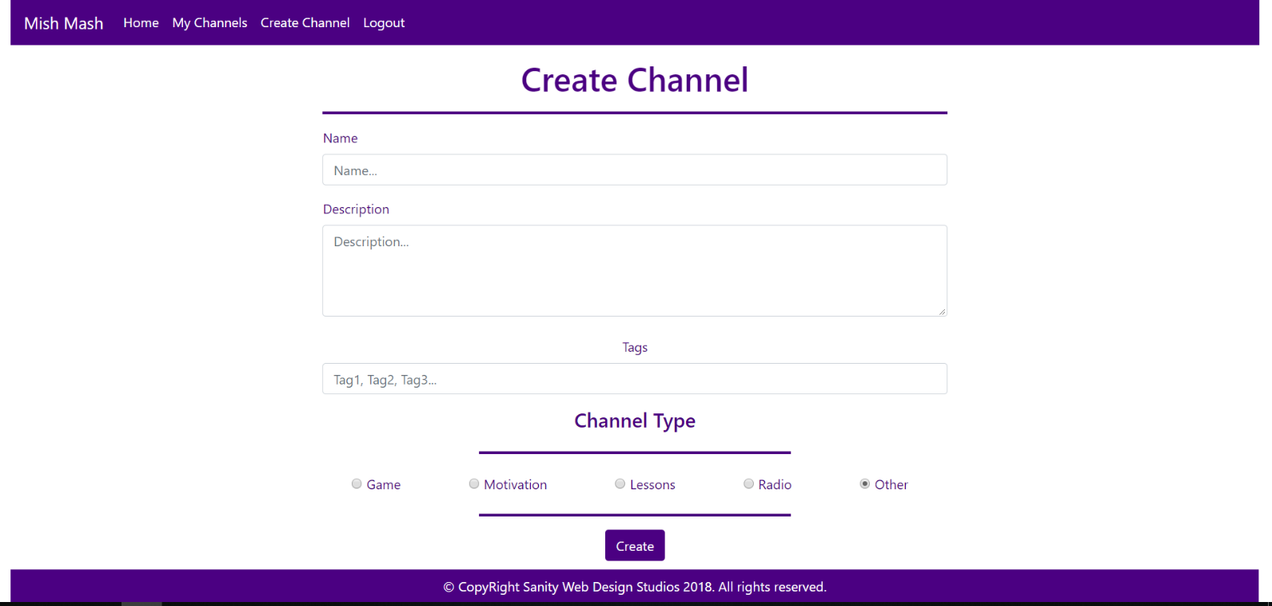

Some of the templates have been given to you in the application skeleton, but the others will be for you to implement, so make sure you implement them correctly. You can use the given ones as helpers.

## Functional Requirements

The Functionality Requirements describe the functionality that the **Application** must support.

The **application** should provide Guest (not logged in) users with the functionality to login, register and **view** the Index page.

The **application** should provide Users (logged in) with the functionality to logout, and view all channels, and **follow / unfollow** a Channel, and **view details** about a Channel.

The **application** should provide Admins (logged in, with role - Admin) with the functionality to logout, and view all channels, and **follow / unfollow** a Channel, and **view details** about a Channel, **create** a Channel.

When you register a new User, it should be assigned with a **role** – User.

### Users

Users can **follow** or **unfollow** Channels. If a Channel is **NOT followed**, it should be represented on the Index page as a rectangular element, which holds **2 buttons** at its bottom – [Follow] and [Details].

* Upon clicking the [Follow] button, the Channel should be added to the Followed Channels of the **current user**.
* Upon clicking the [Details] button, the **current user** should be **redirected** to the Channel’s Details Page.

If a Channel is **followed**, it should be represented on the Index page as a rectangular element, which holds **a simple text** at its bottom – “Following”, with no **functionality** behind it.

### Channels

There are **3 sections** on the Index page:

* Your Channels
* Suggested
* See Other

The Your Channels section holds all of the current user’s Followed Channels. If there are **no such** Channels, it should just be left empty.

The Suggested section holds any Channels, which have at least **1 common tag** with **one** of the **current user’s** Followed Channels.

The See Other section holds all Channels, which are **NOT included** in the Your Channels and Suggested sections.

## Security Requirements

The Security Requirements are mainly access requirements. Configurations about which users can access specific functionalities and pages.

* Guest (not logged in) users can access Index page and functionality.
* Guest (not logged in) users can access Login page and functionality.
* Guest (not logged in) users can access Register page and functionality.
* Users (logged in) can access User LoggedIn Index page and functionality.
* Users (logged in) can access User Channel Details page and functionality.
* Users (logged in) can access the My Channels functionality.
* Users (logged in) can access the Channel Follow functionality.
* Users (logged in) can access the Channel Unfollow functionality.
* Users (logged in) can access Logout functionality.
* Admins (logged in) can access **every functionality** a **normal** logged in User can.
* Admins (logged in) can access Admin LoggedIn Index page and functionality.
* Admins (logged in) can access the Channel Create page and functionality.